Student Name:_______________________

 | Eastern Goldfields College  Mathematics Applications U3&4 2017  Investigation 1 Validation
Working Time: 50 minutes | CALCULATORS ARE ALLOWED Total Marks: 24

Bivariate Data Analysis

Question 1 (9 marks: 2, 2, 5)
The table below shows the hours spent by a sample of 20 high school students watching television and doing homework in a week.

Hours watching TV | 4 | 5 | 5 | 0 | 9 | 6 | 20 | 4
Hours of homework | 10 | 5 | 1 | 2 | 3 | 7 | 9 | 4
Hours watching TV | 6 | 2 | 40 | 5 | 1 | 8 | 17 | 2
Hours of homework | 4 | 1 | 1 | 1 | 1 | 10 | 20 | 1
Hours watching TV | 13 | 1 | 14 | 14
Hours of homework | 14 | 6 | 0 | 9

Some people feel that TV is a distraction to young high school students; in fact, they would claim, ‘the more hours spent by a student watching television, the less hours the student will spend doing homework’.

Complete the following questions and use these data to comment on the above statement.

(a) Decide which is the explanatory variable and which is the response variable in the above comment. (2 marks)

(b) Calculate the statistical measures you will use to decide whether the proposition is reasonable or not. (2 marks)

(c) Use your measures from (b) to comment on the proposition, ‘the more hours spent by a student watching television, the less hours the student will spend doing homework’.
(5 marks)

Question 2 (10 marks: 3, 4, 3)
The diagram below is the scatter plot for the sample in the table above.

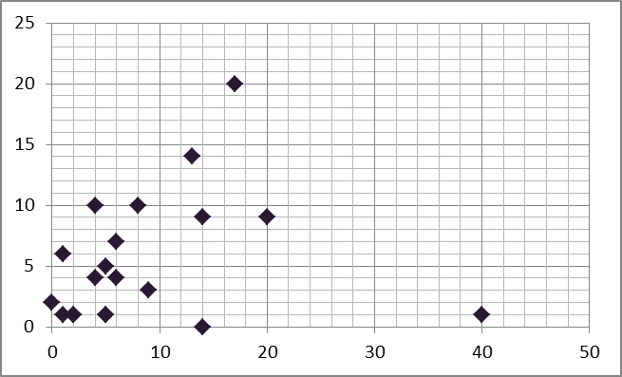

(a) Label the axes and draw the regression line from 1(b) on the graph. (3 marks)

(b) Calculate the equation of the linear regression line, using the variables defined here:
(4 marks)

(c) Using the line of best fit in (b), calculate the residual for the student who watched 17 hours of TV and spent 20 hours doing homework. (3 marks)

Question 3 (5 marks: 1, 1, 1, 1, 1)
Below are the four stages of the Investigation Process. Use the information and data within this validation to address each of these stages.
Stage 1: Clarify the problem and formulae one or more questions that can be answered
with data.
- Is this validation, what was the problem and questions you were required to answer?

Stage 2: Design and implement a plan to collect and obtain appropriate data.

- Data for this validation was given to you. How could you have collected this data if it was not provided?

Stage 3: Select and apply appropriate graphical or numerical techniques to analyse the
data.

- In this validation, what graphical and numerical techniques were used to analyse the data?

Stage 4: Interpret the results of this analysis and relate the interpretation to the original
question and communicate findings in a systematic and concise manner.

- In this validation, what are the findings?

- What could be done to improve your analysis and findings?

~ END OF VALIDATION ~

